Create Autoscaling Group

Step1- Create launch template

There will be different sections while creating a launch configuration template as below

Section 1 - Launch template name and description

--> Launch template name - required
--> Template version description
--> There will be template tag where you can add tag
--> There will be source template option where you can specify a source template if you would like to create a template from another existing template

Section 2 - Launch template contents

--> Give details of Amazon machine image (AMI) name or OS

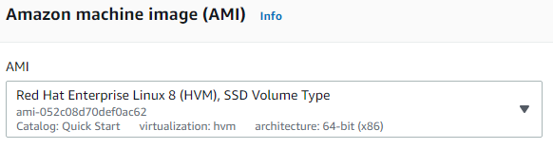

--> Give Instance type - like t2.micro, t2.large
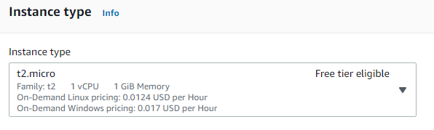

--> Key pair (login) -- give already created key pair or create a new key pair instantly

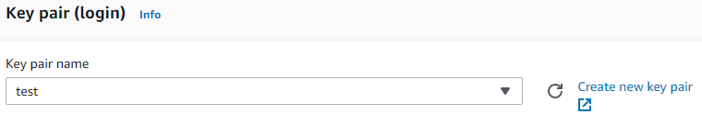

- Network settings - you can select your Networking platform as VPC or EC2 classic

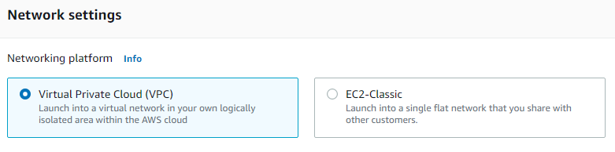
- Security groups – you can select already created security groups.

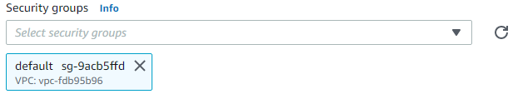

Section 3 - Storage (volumes)

--> you can see Volume type like EBS , Device name like /dev/sda1 , snapshot like snap-0eed80218c5b3d1cf
--> You can change the size of volume and volume type and delete on termination ( yes /no )
--> you can add new volume also
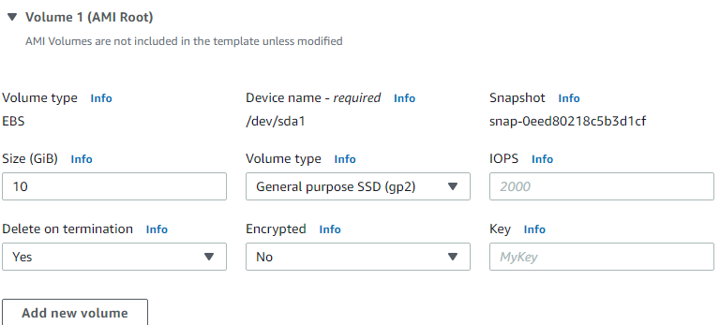
- Resource tag
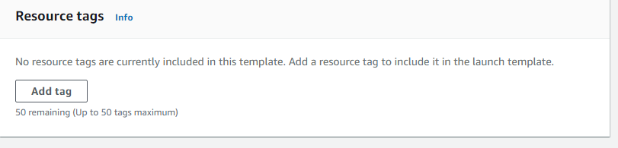

Network interfaces

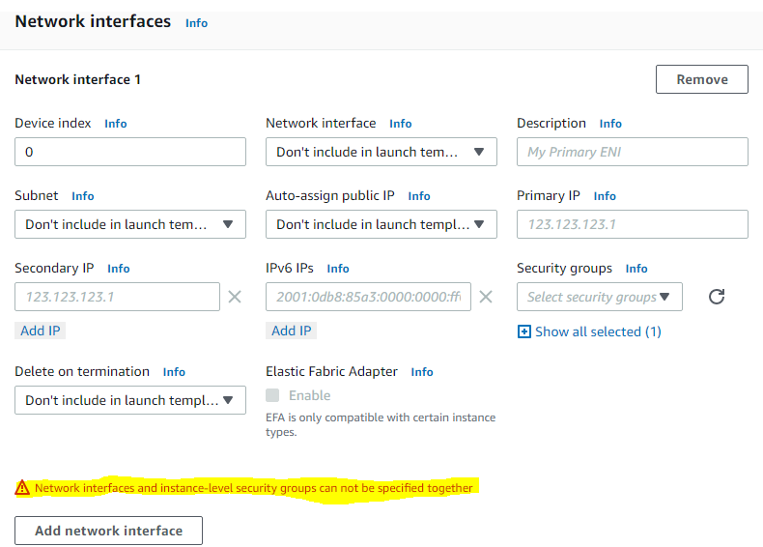

Last section : Advanced details

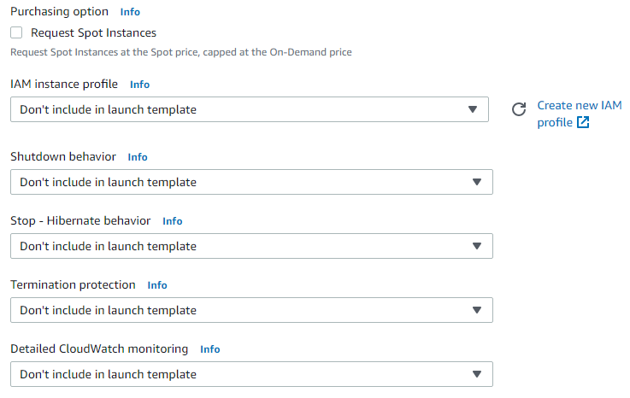
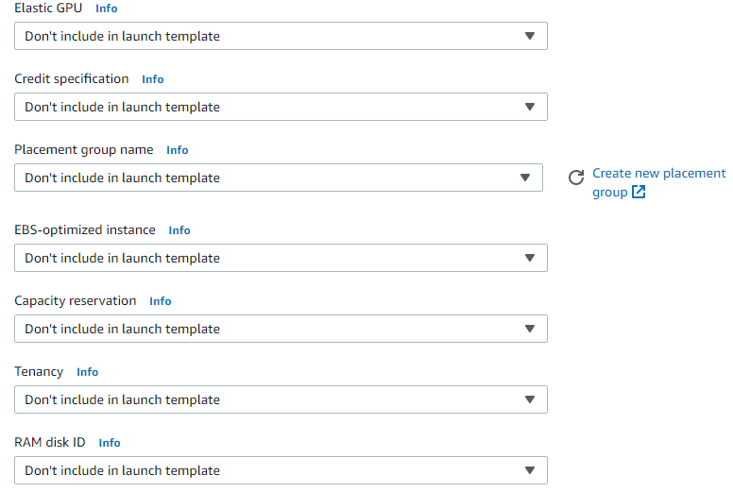
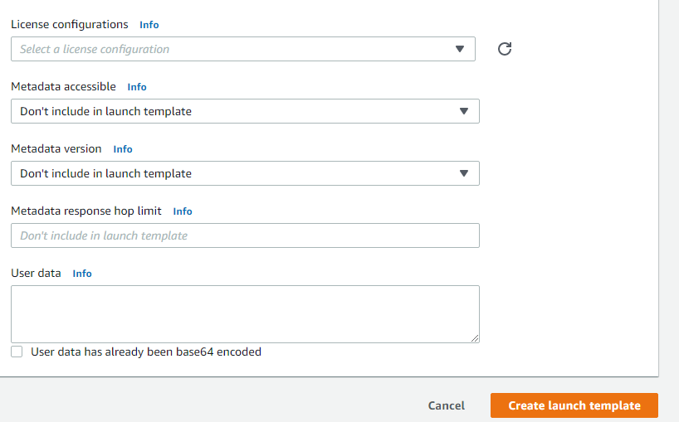

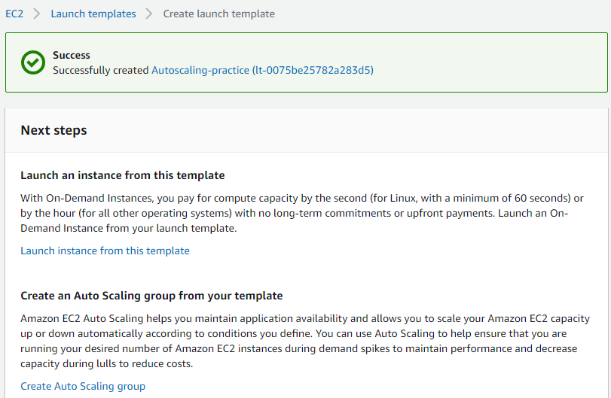

Create launch configuration

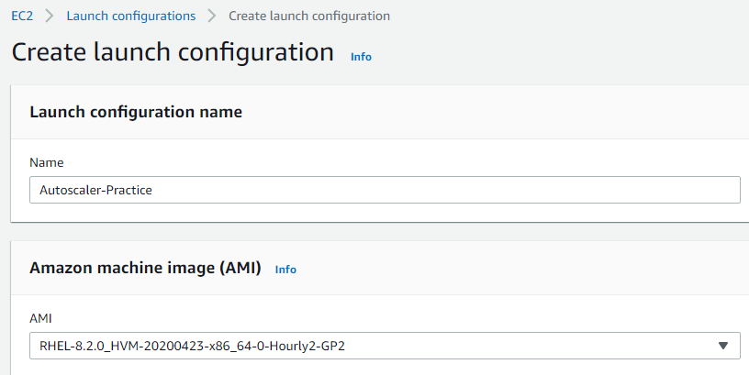

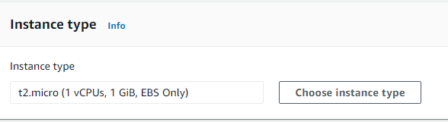

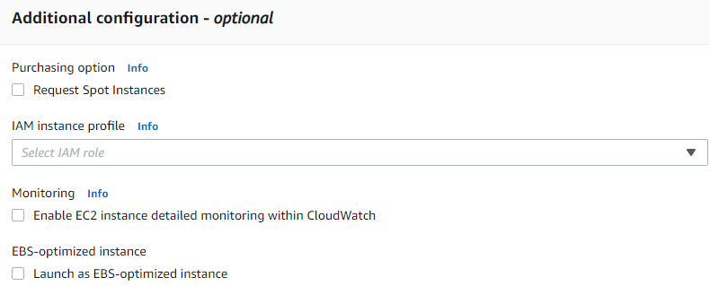

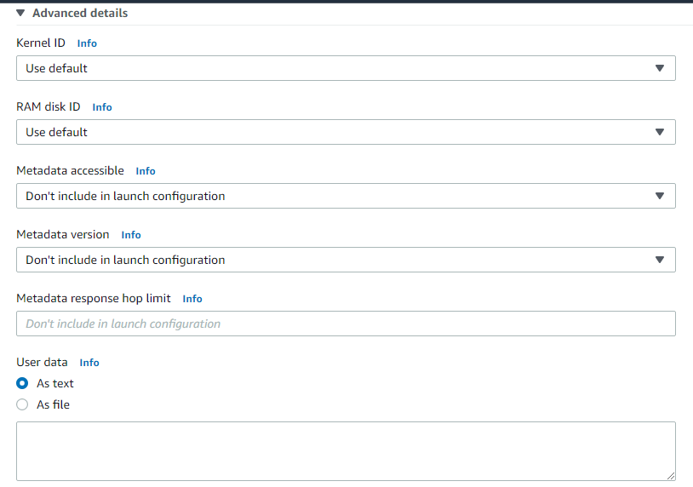

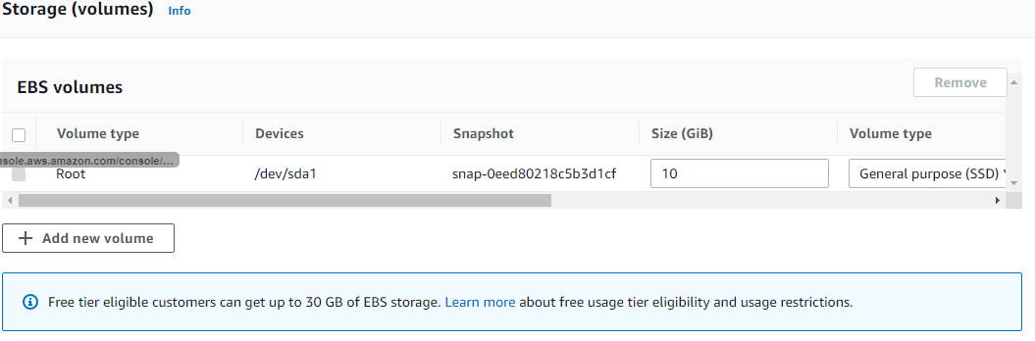

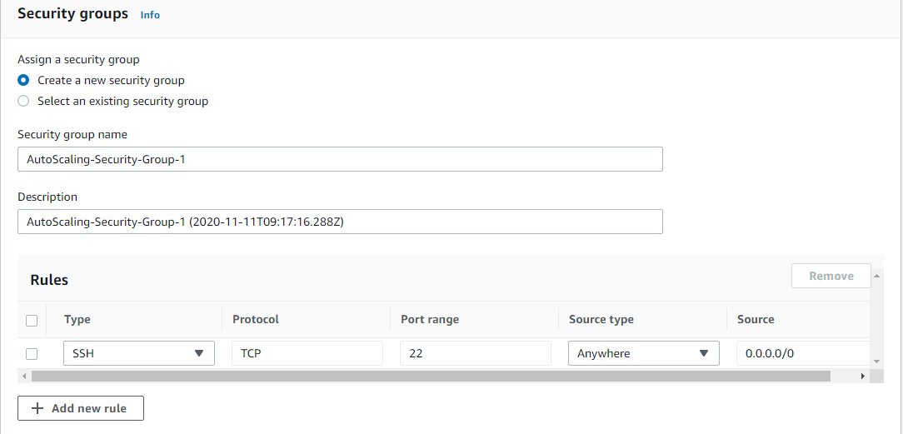

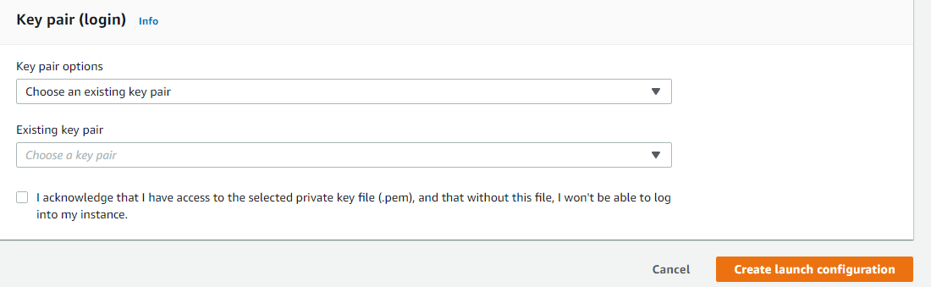

Create Auto-scaling Group
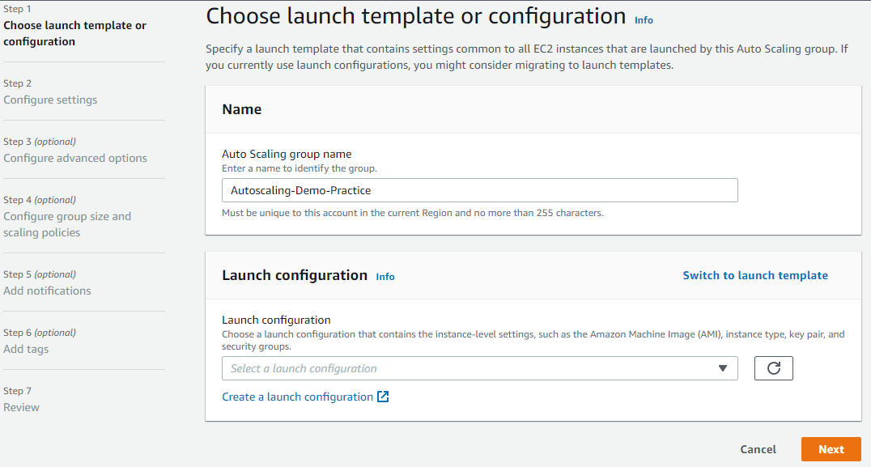

You can switch to launch template or launch configuration

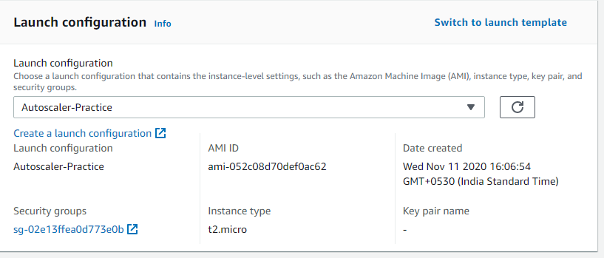

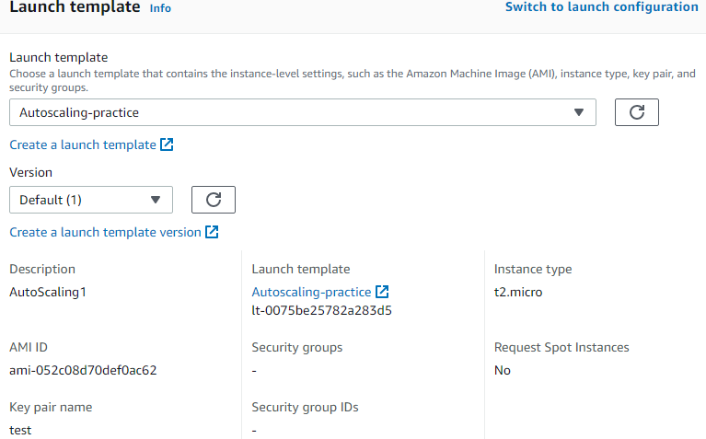

Select VPC and Subnet

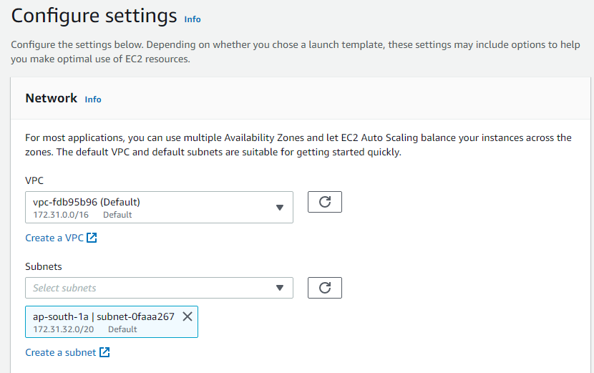

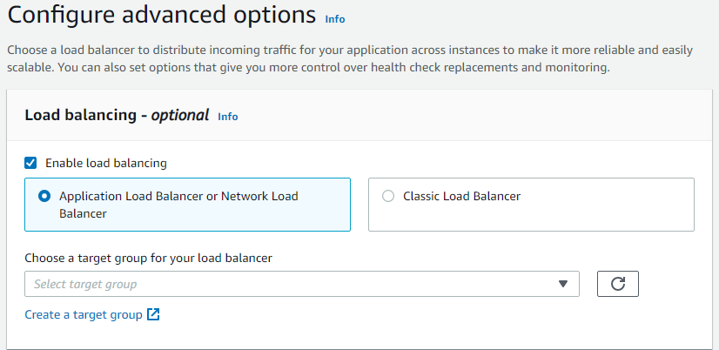

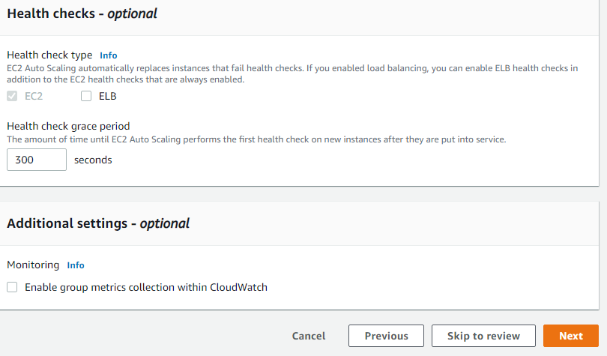

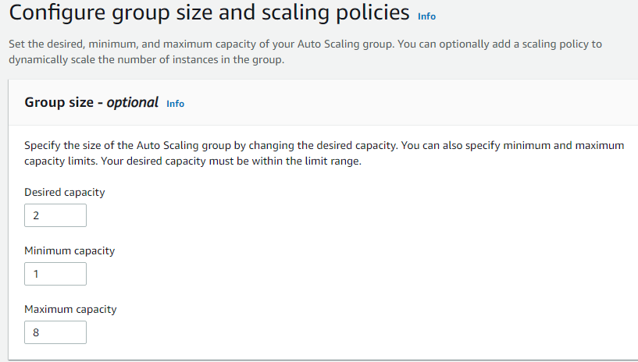

The desired capacity has to be between minimum capacity and maximum capacity.

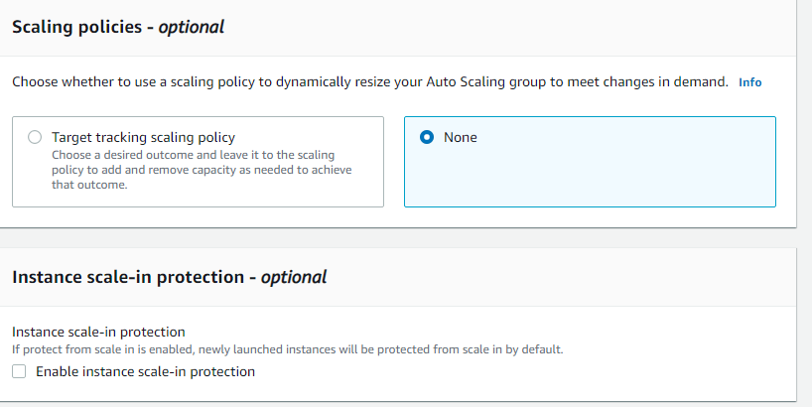

If you want to not to delete the instances when scale-in occurs enable Instance scale-in protection

